QUESTION:
import pandas as pd
import seaborn as sns

# The following code reads all the Gapminder data into Pandas DataFrames. You'll
# learn about DataFrames next lesson.

path = '/datasets/ud170/gapminder/'
employment = pd.read_csv(path + 'employment_above_15.csv', index_col='Country')
female_completion = pd.read_csv(path + 'female_completion_rate.csv', index_col='Country')
male_completion = pd.read_csv(path + 'male_completion_rate.csv', index_col='Country')
life_expectancy = pd.read_csv(path + 'life_expectancy.csv', index_col='Country')
gdp = pd.read_csv(path + 'gdp_per_capita.csv', index_col='Country')

# The following code creates a Pandas Series for each variable for the United States.
# You can change the string 'United States' to a country of your choice.

employment_us = employment.loc['United States']
female_completion_us = female_completion.loc['United States']
male_completion_us = male_completion.loc['United States']
life_expectancy_us = life_expectancy.loc['United States']
gdp_us = gdp.loc['United States']

# Uncomment the following line of code to see the available country names
# print employment.index.values

# Use the Series defined above to create a plot of each variable over time for
# the country of your choice. You will only be able to display one plot at a time
# with each "Test Run".
SOLUTION:
df = pd.DataFrame(employment_us)
plot = df.plot(title="Employment (United States)")
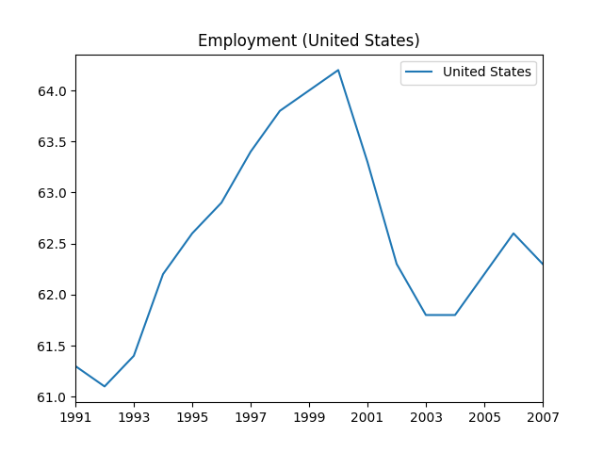
df = pd.DataFrame(female_completion_us)
plot = df.plot(title="Female Completion (United States)")
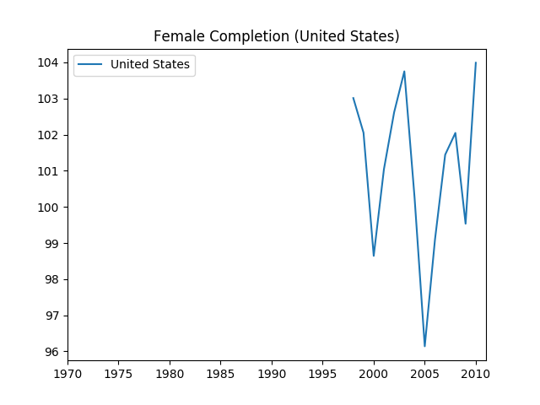
df = pd.DataFrame(male_completion_us)
plot = df.plot(title="Male Completion (United States)") 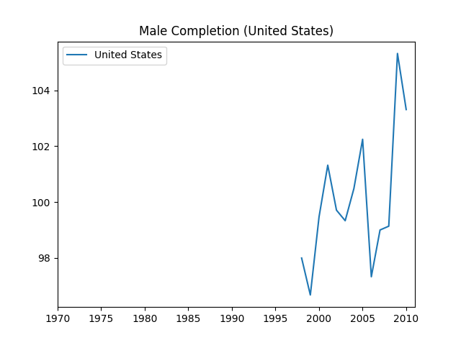
df = pd.DataFrame(life_expectancy_us)
plot = df.plot(title="Life Expectancy (United States)")
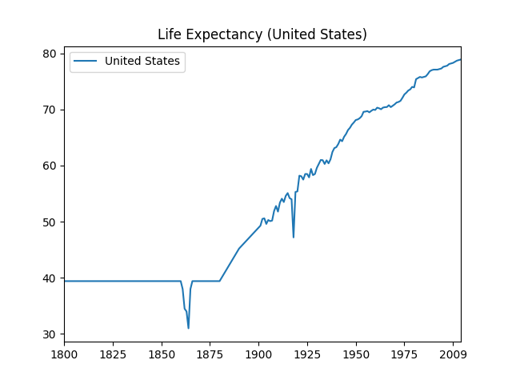
df = pd.DataFrame(gdp_us)
plot = df.plot(title="GDP (United States)")
